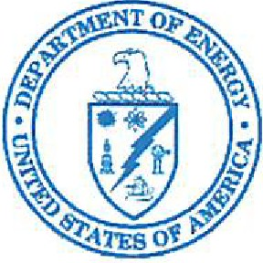
MEMORANDUM FOR:

Department of Energy

National Nuclear Security Administration
P.O. Box 5400 Albuquerque, NM 87185

Jodi Kouts
Program Manager
Export Control Review and Compliance - WMD
Interdiction (ECRC/I)
Nuclear Export Controls (NA-242)

and

Evelyn Prestosh
Deputy Program Manager for
Export Control Review and Compliance - WMD
Interdiction (ECRC/I)
Nuclear Export Controls (NA-242)

FROM: Michael J Douche . Digitally signed by Mlchael J.

Manager
Michael J. Donche Donche
Date: 2021.02.16 14 :30:54 -07'00'

NNSA Organization Property Management Officer (OPMO) Personal Property Branch, NA- APM -1 43
Acquisition Policy & Oversight Divis ion

SUBJE CT: Exception from Destruction Request

In accordance with 41 Code of Federal Regulations Subpart I 09-1-53, Management of High Risk Property, this memo is to formally request your approval of the Exception to the Presumption of Destruction for Trigger List Items intended for Buy-Back. This request was prepared by

Attached: Exception from Destruction Request ---------

This package has been reviewed and received concurrence from the NNSA Organizational Property Management Officer.

If you have any questions or if we can be of further assistance, please contact Michael J. Donche, Manager, NNSA Organizational Property Management Officer at 505-845 -5950.

Attachments

cc w/attachments:

------------------
M. Donche, NNSA

